CMPE679: Deep Learning
Homework 2
CIFAR-10 Image Classification Using a Convolutional Neural Network

Gloria Mbaka
Performed: 2/8/2026
Submitted: 2/9/2026

Instructor: Dr. Liu, Dongfang
TA: Huang, Renzhong; and Renjen, Ishan

By submitting this report, I attest that I neither have given nor have received any unauthorized assistance (including writing, collecting data, plotting figures, tables, or graphs, or using previous student reports as a reference), and I further acknowledge that giving or receiving such assistance will result in a failing grade for this course.
Your Signature: | CGM

Abstract
In this homework, a convolutional neural network (CNN) was implemented, trained, and evaluated for image classification using the CIFAR-10 dataset. The model employs multiple convolutional layers with nonlinear activations and max pooling to extract hierarchical spatial features from color images, followed by fully connected layers for classification. The network was trained using supervised learning with the cross-entropy loss function and the Adam optimizer. Model performance was evaluated using training and test accuracy, loss curves, a confusion matrix, and qualitative visualization of correct and incorrect predictions. The results demonstrate stable training behavior and strong generalization performance, highlighting the effectiveness of convolutional neural networks for image classification tasks.

1. Introduction
Image classification is a core problem in computer vision, where the objective is to assign a semantic label to an input image. Unlike structured data, image data contains strong spatial relationships between neighboring pixels. Fully connected neural networks, such as those used in Homework 1 for MNIST digit classification, are limited in their ability to exploit this spatial structure. Convolutional neural networks address this limitation by using local receptive fields, shared weights, and hierarchical feature learning. In this homework, a CNN was designed and trained to classify images from the CIFAR-10 dataset, which contains color images with greater visual complexity and variability than MNIST. The goals of the assignment were to understand CNN architecture design, train the model using supervised learning, and evaluate its performance using both quantitative and qualitative metrics..

2. Dataset and Problem Definition
The CIFAR-10 dataset consists of 60,000 RGB images of size 32 × 32 pixels, divided into 50,000 training images and 10,000 test images. The dataset contains ten object categories: airplane, automobile, bird, cat, deer, dog, frog, horse, ship, and truck.
Each image is represented as a three-channel tensor corresponding to the red, green, and blue color channels. The classification problem is formulated as a supervised multi-class classification task. Given an input image
$$x∈R^{3×32×32},$$
the model outputs a vector of ten class scores, one for each category. The predicted class corresponds to the index of the maximum score.

3. Data Preprocessing
Prior to training, the dataset was normalized using per-channel mean and standard deviation values computed from the training set. Normalization improves numerical stability and accelerates convergence during optimization. The computed statistics were:
- Mean: (0.4914, 0.4822, 0.4465)
- Standard deviation: (0.2470, 0.2435, 0.2616)
To improve generalization, data augmentation techniques were applied to the training set, including random cropping with padding and random horizontal flipping. The test set was not augmented and was only normalized to ensure a fair evaluation.

4. Convolutional Neural Network Architecture
The convolutional neural network architecture consists of three convolutional blocks followed by fully connected layers for classification. Each convolutional block applies convolution operations with ReLU activation functions and max pooling to reduce spatial dimensions while increasing the number of feature channels.
As the network depth increases, the spatial resolution of feature maps decreases and the learned features become more abstract. After the final convolutional block, the feature maps are flattened and passed through fully connected layers. A dropout layer is applied to reduce overfitting. The final layer outputs logits corresponding to the ten CIFAR-10 classes.

5. Training Methodology
The network was trained using supervised learning. During training, model parameters were iteratively adjusted to minimize a loss function that measures the discrepancy between predicted class scores and true labels.

5.1 Loss Function
The cross-entropy loss function was used for training. For a single input image, the network produces a vector of logits
$$z∈R^{10}.$$
These logits are internally converted into class probabilities using the softmax function:
$$p_{k}=\frac{e^{z_{k}}}{\sum_{j=1}^{10}{e^{z_{j}}}}.$$
Given the true class label $y$, the loss is defined as:
$$L=-log⁡(p_{y}).$$

5.2 Optimization and Backpropagation
Gradients of the loss with respect to all trainable parameters were computed using backpropagation. The Adam optimizer was used to update model parameters due to its adaptive learning rate and stable convergence properties. Training was performed for multiple epochs (20 epochs) using mini-batch gradient descent. Training and test accuracy were evaluated after each epoch to monitor convergence and generalization.

6. Results and Visualization

6.1 Gradient Flow Analysis
Figure 1 shows the gradient flow across selected convolutional and fully connected layers during training. The plotted values represent the L2 norm of the gradients computed for each layer over multiple mini-batch updates. All layers exhibit non-zero gradients throughout training, indicating that learning signals propagate effectively through the network. Earlier convolutional layers show larger gradient magnitudes, while deeper convolutional and fully connected layers exhibit smaller but stable gradients. This behavior is expected and confirms the absence of vanishing or exploding gradient problems.
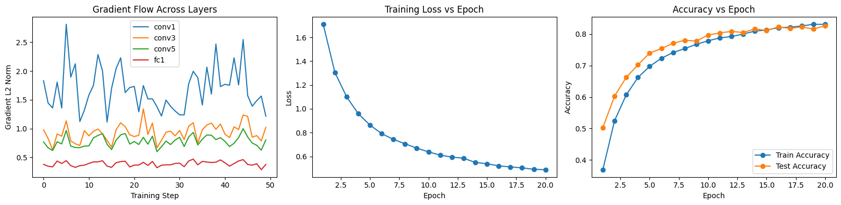

Figure 1: Gradient flow across selected convolutional and fully connected layers during training, showing stable non-zero gradient magnitudes.

6.2 Training Loss and Accuracy
Figure 2(i) shows the training loss as a function of epoch. The loss decreases steadily throughout training, indicating effective optimization and convergence of the model.
Figure 3(ii) shows the training and test accuracy across epochs. Both curves increase consistently and remain closely aligned, demonstrating strong generalization and minimal overfitting.

(ii)
(i)
Figure 2: (i) Training loss versus epoch for the convolutional neural network trained on the CIFAR-10 dataset. (ii) Training and test accuracy versus epoch for the CIFAR-10 classification model.

6.3 Confusion Matrix
Figure 3 presents the confusion matrix computed using predictions on the test dataset. The matrix exhibits strong diagonal dominance, indicating correct classification for most samples. Misclassifications primarily occur between visually similar categories such as cats and dogs, which is expected given the low resolution of CIFAR-10 images.
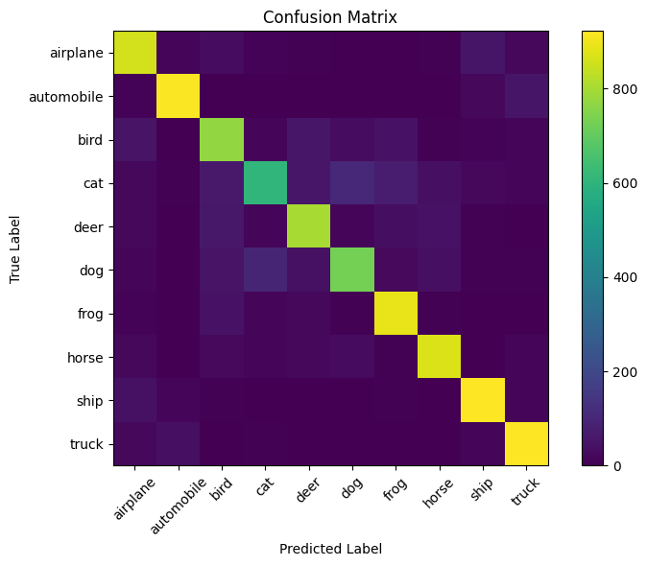
Figure 3: Confusion matrix showing class-wise prediction performance on the CIFAR-10 test set.

6.4 Correct and Incorrect Predictions
Figure 5 shows examples of correctly and incorrectly classified test images. Correct predictions demonstrate the model’s ability to identify distinctive visual features across multiple object categories. Incorrect predictions often involve images with low contrast, background clutter, or ambiguous object features. These errors are consistent with the confusion matrix and reflect inherent dataset challenges rather than model instability.
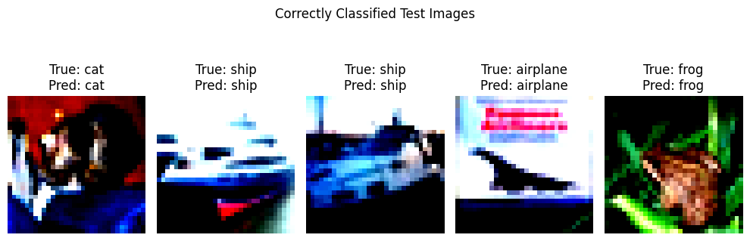
Figure 4: Examples of correctly classified CIFAR-10 test images illustrating qualitative model performance.
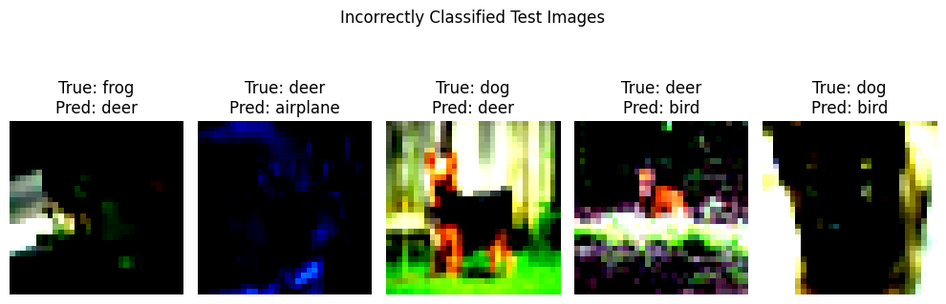
Figure 5: Examples of incorrectly classified CIFAR-10 test images illustrating qualitative model performance.

7. Discussion and Lessons Learned
The results demonstrate that convolutional neural networks are well suited for image classification tasks due to their ability to capture spatial and hierarchical features. The model achieved strong test accuracy and exhibited stable training behavior. Most classification errors occurred between visually similar classes, which is expected given the limited resolution of CIFAR-10 images. Overall, the network learned meaningful visual representations and generalized well to unseen data.

8. Conclusion

In this homework, a convolutional neural network was successfully implemented and trained for CIFAR-10 image classification. The model achieved strong performance on the test set and demonstrated stable convergence during training. Quantitative metrics and qualitative visualizations confirmed effective feature learning and generalization. This assignment builds upon the concepts introduced in Homework 1 and highlights the advantages of convolutional architectures for image-based learning tasks.

9. AI Usage Disclosure

Artificial intelligence tools were used to support learning, clarify deep learning concepts, debug implementation issues, and assist in organizing the written report. All code was written, executed, and verified by me, and all results were generated from my own implementation.

References
- LeCun, Y., Bottou, L., Bengio, Y., & Haffner, P. (1998). Gradient-based learning applied to document recognition. Proceedings of the IEEE, 86(11), 2278–2324.
- Goodfellow, I., Bengio, Y., & Courville, A. (2016). Deep Learning. MIT Press. https://www.deeplearningbook.org/
- Paszke, A., Gross, S., Massa, F., et al. (2019). PyTorch: An imperative style, high-performance deep learning library. Advances in Neural Information Processing Systems, 32.
- Krizhevsky, A., & Hinton, G. (2009). Learning multiple layers of features from tiny images. University of Toronto, Technical Report. https://www.cs.toronto.edu/~kriz/cifar.html

